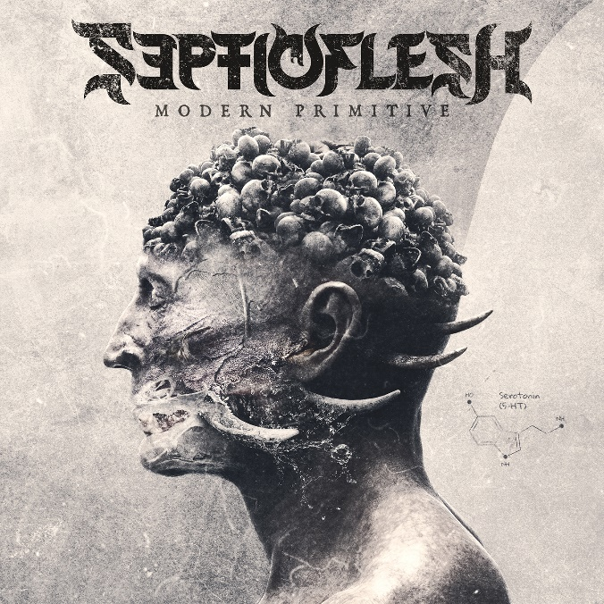

SEPTICFLESH

»Modern Primitive«

OUT: May 20th 2022
Line up: | SEPTICFLESH online:
Seth Siro Anton | Vocals, Bass  Christos Antoniou | Guitar, Orchestra  Sotiris Anunnaki V | Clean Vocals, Guitar, 12 String Guitar  Psychon | Guitar  Kerim “Krimh” Lechner | Drums | https://www.facebook.com/septicfleshband  https://www.instagram.com/septicflesh_band  https://twitter.com/septicfleshband  https://www.septicflesh.com/
2022 – 31 years after the release of their debut EP “Temple Of The Lost Race”, SEPTICFLESH are set to deliver their latest longplayer, entitled Modern Primitive.
When it comes to history, the band has a lot to offer. On the one hand, there is the long history of the band and over 30 years of experience in the business, which can be traced back to the three founding members Seth, Christos and Sotiris. On the other hand, it is about history if you look purely at the music of the Greeks. The lyrics, the aspects treated, the message... You can observe the art on several tracks and yet it is always expanded and decorated with new elements. This is also the case on the latest masterpiece of SEPTICFLESH!
Album number eleven of the band, which is the first album under Nuclear Blast, is not less complex in the field of composition and lyricism than the albums before. But this time the band focuses more powerfully on the message and the theme that is addressed with the music and stands behind it. The thought-provoking, which already draws attention to the title of the album: Modern Primitive.
“The title is an impulse to think, it is not particularly obvious" says Sotiris Anunnaki V. With this, the band wants to encourage people to think and take a closer look at the motives that SEPTICFLESH address. "This shouldn't surprise people who have been involved with our music for a while, though," Sotiris Anunnaki V says with a smile. "We provide our listeners with so much food for thought musically and lyrically, though, that it shouldn't be hard to synthesize the clues into a big picture." An important piece of this intricate mosaic is also the album cover, which perfectly showcases the brutality as well as the elegant epicness of the Greeks. It shows a human skull drawn in detail, which is broken up in a flowing transition by sharp thorns. Beauty meets horror. Sotiris explains the intention behind this first visual impression of Modern Primitive. "You have as a foundation here a motive which is well-constructed and perfect, the human head. In our interpretation, however, this loses its primary original form and becomes something else: It evolves. The cover, in its obviousness, is meant to reflect this very situation in which humanity still finds itself today." Slightly revealing criticism of modern society, he continues, "We are constantly evolving, but instead of taking a step forward, our evolution is regressive. We still have primitive borrowings and traits deeply embedded in our genes. This can be good, but it is not always. History just keeps repeating itself, with a new cover and new images."
What is remarkable with SEPTICFLESH and is far from being the rule, is the continuity and the building on each other of the albums. Also in the past, lyrical elements were always incorporated that are based on opposites. For example, the idea of heaven and hell, good and evil or development and destruction has often been a metaphorical image of a message in SEPTICFLESH's lyrics. Also on the newest record these social topics are partly approached critically. This happens not only for the reason to deliver good music and sophisticated lyrics, but much more because SEPTICFLESH feel obligated to do so.
"I feel like we have a responsibility there, too," says Sotiris. "We are not only a band that deals with just such topics as civilization, further development but also destruction, but we also see ourselves as thinkers: whatever leaves us with a strong impression finds its way into our music. This is quite natural, especially in times like these, which are so difficult for all of us.”
Therefore, the work SEPTICFLESH put into their music is by no means self-evident but requires patience. Because every detail must fit in the respective song so that the final construct is coherent. Accordingly, not every idea and every thought makes it onto the album. “Sometimes just a small detail is not right and the entire construct is invalid. There's no point in trying to make it fit by hook or by crook. It's important that all the parts fit together one hundred percent" admits Sotiris.
But of course it is still fun and a passion for the band to create and compose new music. The mood at the release is of course a bit more tense, but the belief in one's own ability outweighs the fear of failure guitarist Christos Antoniou honestly expresses. “You feel relaxed in the middle of the process to be honest, in terms of creation. Anxiety, of course it comes with every release, but it is something natural. Until now, we can see that all our efforts have been rewarded and we always aim for the best.
And talking about the best, SEPTICFLESH picked nine songs to put on their newest album. As on the previous albums, the band continues its collaboration with the Filmharmonic Orchestra of Prague, which has existed since the reunion of the band in 2007. The many elements of the orchestra, which has become an integral part of many SEPTICFLESH songs, have been expanded this time with an entire adult and children's choir.
The album was once again produced by the renowned producer Jens Bogren who is responsible for the outstanding mix. Despite the many different emotions reflected in the songs, the band in collaboration with the producer managed to create a gloomy and empowering atmosphere, which does not weaken the hardness and memorability of the songs. The album cover, on the other hand, is the work of singer and bassist Seth Siro Anton, who has also been artistically active for other bands such as Paradise Lost or Moonspell and created visual aesthetics for them. But also when it comes to songwriting Seth has always been involved and describes how he came up with some ideas for this album. “Besides having the task of shaping the visual character of Modern Primitive, a lot of song ideas came to my mind while playing a 12 string electro acoustic guitar. That led to a more organic sounding approach to the album.”
No matter how you take it, art-wise SEPTICFLESH has once again done everything possible. From the album cover to the lyricism to the arrangements of the individual songs, Modern Primitive shows what SEPTICFLESH still stand for five years after their last album… and this time more than ever.

